JOURNAL OF E-LEARNING AND KNOWLEDGE SOCIETY Vol. 19, No. 4 (2023), pp. 1-8

### Navigating the Digital Classroom: Exploring the Effectiveness of Online-Based Learning

#### Benedictus Cristiano Budia,1, Laser Clauss Latupeirissab

*aSchool of Computer Science, Bina Nusantara University, Tangerang, Indonesia*

*bSchool of Computer Science, Bina Nusantara University, Tangerang, Indonesia*

*(submitted: ; accepted: ; published: )*

**Abstract**

**KEYWORDS: Online Based-Learning, technology**

**DOI**

soon

**CITE AS**

Budi, B.C., & Latupeirissa, L.C. (2024). Navigating the Digital Classroom: Exploring the Effectiveness of Online-Based Learning. *Journal of e-Learning and Knowledge Society*, *19*(4), 1-8.

doi

##### Introduction

Online based learning is learning not directly, but online. The online based learning has become a main focus in modern education, especially in facing global challenges like the pandemic which forces drastic adjusment in learning method. In an era where technology plays an active role in changing the role of distance education from an alternative to the classroom into a social transformation by providing access to education for all[1].

This effectiveness is very important because it can improve people's performance in learning where this can be influenced by many things. This can be seen in the current era where online based learning must have a positive impact on users, not become an obstacle. These positive impacts can be various, such as being able to enable people to access a wide range of materials without limitations and increasing collaboration between students, supporting students' constructivist learning and so on[1], [5].

However, in implementing online based learning, there are challenges that need to be faced. This challenge usually interferes with the effectiveness of implementing online based learning. Therefore, we want to research what factors influence the effectiveness of online based learning. We also want to know how long people have been using online based learning. This can be a solution later for obstacles in implementing online based learning[6].

1 corresponding author - email: [hiwaabdekhoda@gmail.com](mailto:hiwaabdekhoda@gmail.com) **1**

© Italian e-Learning Association

1. **Related Work**

*ROLE OF OPEN EDUCATIONAL RESOURCES*

T. Caswell, S. Henson, M. Jensen, and D. Wiley explore the pivotal role of Open Educational Resources in supporting free education. They argue that technology has reduced the reproduction costs of educational content to almost nothing, enabling educators to share their course materials globally at minimal or no cost. This significant shift not only democratizes education but also repositions distance education from an alternative to traditional classroom settings to a transformative force in society [1].

Despite the supply of high-quality open educational resources, their usage is quite low which brings questions to why. Richter and McPherson explore the low usage of the resources, suggesting that a capable supply of resources, does not guarantee sustainable accessibility. They emphasize the need to adapt these resources to local contexts, making it more relevant in various educational settings and geographical locations. The paper also dives into the challenges of online learning in conventional education in developing countries with high illiteracy. The authors conclude that a subtle approach, is essential for integrating high-quality open educational resources into various educational landscapes[3].

*STUDENT ENGAGEMENT AND LEARNING OUTCOMES IN ONLINE LEARNING*

Gray and DiLoreto delve into the impact of course structure, learner interaction, and instructor presence on student satisfaction and perceived learning in online learning environments. Their research emphasizes the importance of student engagement, revealing how it mediates the relationship between the design and delivery of online courses and their effectiveness in enhancing learning outcomes [2].

Chen and Jang's study researches the motivation within online learning from the perspective of Self-Determination Theory. Their research underscores the importance of addressing learners' motivational factors and the critical role of contextual support in igniting the motivation to learn. The authors implemented structural equation modeling to analyze data from participants in online certificate programs, revealing that the satisfaction of learners' needs for autonomy, competence, and relatedness mediates the relationship between contextual support and learner motivation. Although their findings indicated that such motivational factors did not directly predict learning outcomes, they emphasized the necessity of integrating supportive strategies that cater to the individual needs of learners to enhance their motivation effectively [4].

*TECH FOUNDATIONS AND DIGITAL LITERACY FOR ONLINE LEARNING*

Watson and Lee Watson’s paper provides an investigation of Learning Management Systems (LMS), looking into their development, functionality, and differentiation from similar concepts such as Course Management Systems (CMS) and Learning Content Management Systems (LCMS). The authors argue that LMS is a foundation for transitioning from the Industrial to the Digital Age which involves focusing on educational paradigms that focuses on student-centered approaches, flexible customization to meet various student needs, and the integration of technology to support individualized learning pathways[7].

Akhyar et al. made a study to find the impact of digital literacy on learning outcomes among students engaging in online learning. Using a quantitative approach with 348 students as the sample, the study uses simple linear regression analysis to examine the relationship between digital literacy and learning outcomes. The method reveals a positive correlation between them, with digital literacy having 37.1% of the variance in students' learning outcomes. This points out the vital role that digital literacy contributes in creating effective online learning environments. The study's results highlight the need for educational stakeholders to prioritize the development of digital literacy skills among students to enhance their learning outcomes in online settings[8].

1. **Methodology**

This chapter goes over our mixed-methods (Qualitative & Quantitative) approach to investigate the effectiveness of online learning. By collecting qualitative and quantitative data and analyzing them based on survey response and literature review. This mixed-methods approach will allow us to get a comprehensive understanding about the factors that affect online learning effectiveness and the metrics of people that use online learning services.

1. *Data Collection*

Survey Methodology  
We use survey methods to get general data such as age, gender, etc. Apart from that, we also collect data that supports our paper, such as motivation, reasons for choosing online based learning applications and so on. We made this survey targeting students who are currently studying around the age of 18-25, where at that age people have already used online based learning. That way, we can get important data to develop our paper

1. *Quantitative*  
   Quantitative data will be collected based on answers from survey respondents that includes metrics such as age, occupation (Student / Non-Student), demographics and frequency of using online learning.
2. *Qualitative*

Qualitative data will be collected based on answer from survey that will dive into various personal questions like learning barriers, personal motivation and improvement suggestions for online learning platforms.

1. *Data Analysis*

Literature Review

We use the literature review method because we also want to know important information from several previous papers which discuss online based learning/are close to the topic of online based learning. This is used to support our paper to be more valid. So apart from the survey, we also compared it with a literature review to make it more valid. From this literature review we get information about what factors influence the effectiveness of online based learning, whether web interaction influences it or not, what CMS and LMS are, the average classification of samples that use online based learning and so on. We can get this from the abstract, research method, and conclusions.

1. *Quantitative*

We get quantitative data from several papers use Literature Review where we look at the results/graphs of the results of the paper and then draw conclusions, such as the average age of the sample used in the paper, occupation, how long people have used online based learning from the sample.

1. *Qualitative*

We get qualitative data from several papers using Literature Review method where we see the summary results of the paper. This summary result can be from the conclusion, abstract of a paper

1. Hypotesis Testing  
   We hypothesize that the level of effectiveness of online based learning is influenced by external and internal factors. Apart from that, we also hypothesize that a higher level of satisfaction with using online based learning is influenced by a high level of effectiveness. Thursday will compare this hypothesis with the data we will collect
2. **Result and Discussions**

This study surveyed people to find out if they felt effective when using online based learning. In our survey, we found that the students who completed the survey found it effective depending on other factors. Our survey had 54 people of which almost all were students.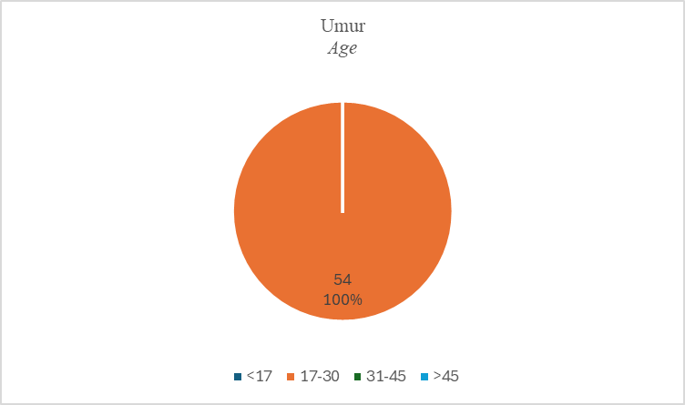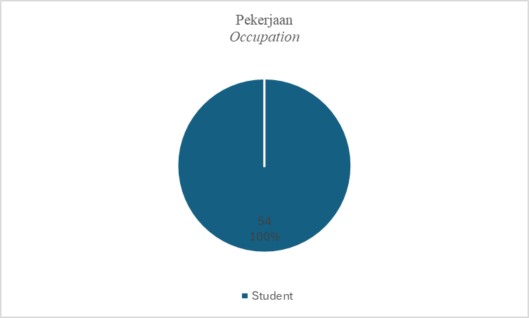This is evidenced by the participant's age and occupation from the survey diagram above. Students here can be students or students. However, we have filtered and distributed this survey within the scope of students, especially Bina Nusantara students. So from the diagram it is concluded that 100% are students who are studying.

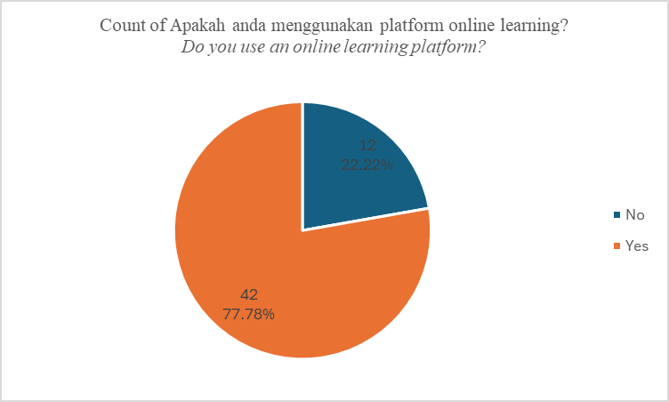The survey also found that 77.8% of students use online-based learning platforms. So the people who use it are about 42 out of 54 people.  
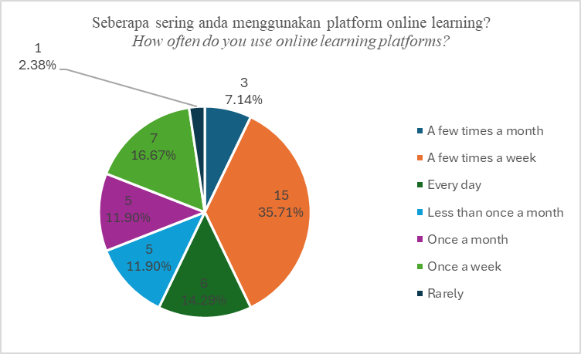Those who use online-based learning platforms also use online-based learning almost all the time as can be seen from the diagram. There are students who use it every day as much as 14.3%, once a week as much as 16.7%, several times a week as much as 36.5%, once a month as much as 11.9%, less often than once a month as much as 11.9%, several times a month as much as 7.1%, and rarely as much as 2.4%. This proves that online-based learning is important because most of the students still use it.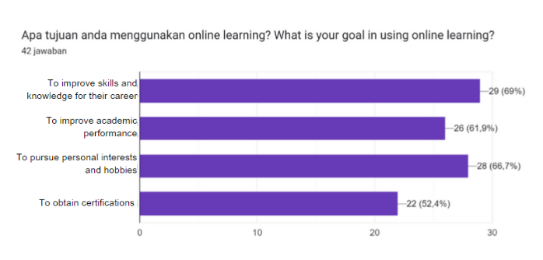There are many purposes of using online-based learning, such as improving skills and knowledge for careers (69%), improving academic performance (61.9%), pursuing personal interests and hobbies (66.7%), and obtaining certification (52.4%).  
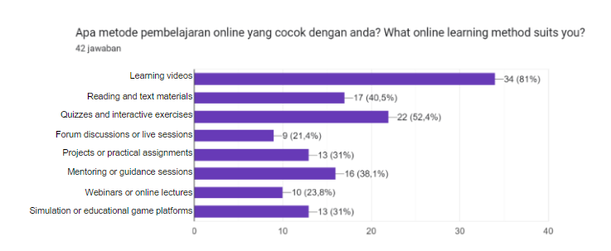In addition, the survey found that the most suitable feature for students is learning videos which can be seen from the bar graph of the longest percent of 81%. There are also other features such as readings and text materials (40.5%), interactive quizzes and exercises (52.4%), forum discussions or live sessions (21.4%), practical projects or assignments (31%), mentoring sessions (38.1%), webinars or online lectures (23.8%), simulation platforms or educational games (31%). From this, we can understand the features preferred by students.

Diagram jawaban Formulir. Judul pertanyaan: Platform online learning mana yang anda gunakan?
Which online learning platform do you use?. Jumlah jawaban: 42 jawaban.From the following survey, it was also found that students use several online-based learning platforms, such as Udemy (14.3%), Skillshare (9.5%), YouTube (95.2%), MySkill (11.9%), Coursera (16.7%), dicoding (2.4%), Duolingo (4.8%), github (2.4%), Quipper (2.4%). The graph also shows that the most widely used is YouTube.

|  |
| --- |
| Faktor apa saja yang mempengaruhi anda memilih platform tersebut? *What factors influenced you to choose this platform?* |
| Price and quality |
| Easy to use |
| Universal |
| Effectiveness |
| Ease of access and types of courses provided |
| Easy to find |
| Popularity |
| Recommendations from the internet or friends |
| Recommendations |
| Need to learn certain fields needed in the future |
| Improving skills |
| Features |
| Practical and easy to use |
| Easy |
| Interesting |
| Funny |
| Free |
| Easy to access |
| Free and many tutorials, not just the ones chosen before |
| Easy to understand |
| Ease of access and comprehensive information |
| Comprehensive |
| Presentation of the material by the instructor |
| Attractive UI, intuitive, straight to the point, easy to access |
| Course completeness, cost, duration |
| Free and many channels |
| Direct collaboration with various top companies in the world |
| Practical |
| Easier to use and free |
| Content of the material |
| Many choices, easy to access, trend and habit |
| Convincing and free |
| Entertaining |
| Easy to access |
| Affordable cost |
| Complete course material |
| Easy access, affordable price, adequate material |
| Affordable cost, flexible, and does not interfere with activities |
| Recommendations from people |
| Material of interest |
| Easy to access |
| Interesting |
| Complete material, easy access |

We also got the factors from the survey results of students' opinions. Here, we mentioned the factors they choose an online-based learning platform, such as price and quality, easy to access/use, universal, effectiveness, types of courses provided, easy to search, popularity, recommendations from the internet/friends, skill investment for the future, features, practical, interesting/funny, free, many tutorials, easy to understand, complete, delivery of material from the teacher, intuitive, straight to point, cost, duration, collaboration with various top companies, many choices, has become a trend and habit, entertaining, material, flexible, and concerns that are in demand.

Diagram jawaban Formulir. Judul pertanyaan: Seberapa puas anda dengan kualitas dan kuantitas konten di platform tersebut?
How satisfied are you with the quality and quantity of content on the platform?. Jumlah jawaban: 42 jawaban.The results of the following survey also found that there are still students who are neutral as much as 16.7% towards the quality and quantity of content on the platform. In addition, there are also students who are satisfied as much as 54.8%, and very satisfied as much as 28.6%. Overall, students are satisfied with the quality and quantity of the platform's content but something can still be improved because there are still those who are neutral.

Diagram jawaban Formulir. Judul pertanyaan: Seberapa puaskah anda terhadap fitur pada platform online learning yang anda gunakan?
How satisfied are you with the features of the online learning platform you use?. Jumlah jawaban: 42 jawaban.In addition, based on the platform features used, there are students who are very satisfied as much as 21.4% around 9 students, satisfied as much as 50% around 21 students, neutral as much as 26.2% as much as 11 students, and less satisfied as much as 2.4% around 1 person. From this, it can be seen that most students are satisfied but there are still those who are neutral and even less satisfied. That means there are still features that need to be further improved.

Diagram jawaban Formulir. Judul pertanyaan: Seberapa puaskah anda terhadap performa platform online learning yang anda gunakan?
How satisfied are you with the performance of the online learning platform you use?. Jumlah jawaban: 42 jawaban.From the survey results, based on the performance of the platform, there are students who are very satisfied as many as 26.2% around 11 students, satisfied as many as 54.8% around 23 students, neutral as many as 19% around 8 students. So there is still something that needs to be improved again for the performance of the platform because there are still those who choose neutral, which means that the performance can still be developed / improved to make it more attractive.

Diagram jawaban Formulir. Judul pertanyaan: Apakah platform yang anda gunakan berbayar?
Is the platform you use paid?
. Jumlah jawaban: 42 jawaban.Students also mostly choose platforms that are free. can be seen from the graph, there are students who do not use paid platforms as many as 69% around 29 people and those who use paid platforms are 31% around 13 people.

|  |
| --- |
| Kira-kira berapa banyak uang yang anda  gunakan untuk berlangganan atau membeli sebuah course?  *Approximately how much money do you spend on a course?* |
| Total maybe >1,000,000 |
| <100 |
| I don't know, my mom registered for me |
| 20-50 thousand per month |
| 40k |
| At most 200k per course |
| ~500k |
| Buy if needed |
| 250,000 - 350,000 |
| Usually Rp 100,000 on Udemy |
| 200k / more |
| Rp 300,000.00± |
| look for ones below 300k |

Students who use this paid platform usually spend from IDR20.000 to IDR1000.000 in a course. However, overall students choose IDR200.000 to IDR300.000.

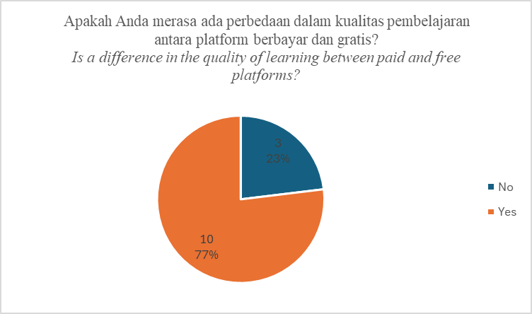These 13 students were also asked about the difference in quality between free and paid platforms. A total of 23% about 3 students felt that free platforms and paid platforms were the same in quality. However, 77%, around 10 students, felt that there was a difference in quality between free and paid platforms,

|  |
| --- |
| Jika Ya, apa saja perbedaannya?  *If yes, what are the differences?* |
| Paid courses usually have more structured learning, while free ones do not. |
| Quality |
| Access |
| Quality and presentation of the material, ad-free videos |
| More substantial material providing a clear picture of the work environment |
| Depth of learning |
| Higher quality material and mentoring |
| Paid courses usually have more comprehensive material |
| The material presented is more in-depth and exclusive, sometimes including discussion sessions with mentors/peers, making it more efficient |
| Increased knowledge |

We also got the quality differences from the survey results, such as more structured paid platforms, quality, access, material delivery, ad-free, more weighty material, depth of learning, more complete, discussion sessions on paid platforms, and broader knowledge.

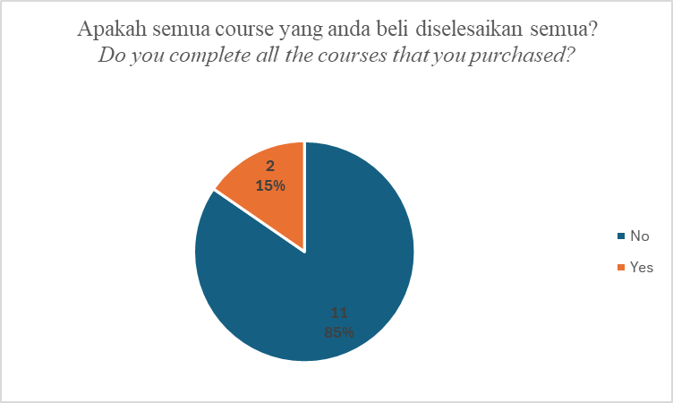Of the 13 students who purchased courses on paid platforms, there were students who did not complete the course as much as 85% around 11 students and those who completed only 15% around 2 students.

|  |
| --- |
| Jika iya, mengapa?  *If yes, why?* |
| Because it's necessary |
| Because to obtain a certification |

The survey results also stated that they worked on the course because it was necessary and could get certification.

|  |
| --- |
| Jika tidak, mengapa?  *If not, why?* |
| Personal reasons |
| Lack of time (lazy) |
| Filling free time is not a main priority |
| Time |
| Laziness, too much content, already learned |
| Too much and only using what is needed |
| Other schedules take priority |
| Haven't finished learning it yet |
| Busy with college and part-time job |
| Some difficulties in doing it |
| Often distracted |

On the other hand, they did not do the course for various reasons, such as personal reasons, laziness, time, not a top priority, too much content, already learnt, often distracted, difficulty when, and busy schedule.

|  |
| --- |
| Hal apa saja yang anda tidak sukai dari platform yang anda gunakan?  *What are the things you don't like about the platform that you use?* |
| Lack of interactive training and learning |
| None |
| Too many ads |
| Good features are expensive |
| None |
| Too many ads |
| Ads |
| Many are paid, cannot be accessed, and have no reviews |
| Paid |
| None |
| Ads |
| Too many confusing interfaces |
| Not interactive enough |
| Limited content |
| Boring |
| Not interactive |
| Downloads but poor quality |
| YouTube: there are ads, mostly unimportant segments like intros, sponsors, etc. |
| Lack of more detailed information |
| Shocking ads |
| Content material sought is sometimes not appropriate |
| None |
| Difficult to choose a course that suits me |
| Ads |
| No good user-friendly system yet |
| Ads that disrupt study time |
| Requires a stable internet connection, sometimes hard to learn the UI |
| None, but I haven't delved into it, so it's hard to assess right now |
| If there is no video tutorial on how to solve something I'm having trouble with on YouTube |
| Videos that are sometimes invalid |
| Some courses lack discussion forums, so when there's a problem, we have to find the solution ourselves |
| Of course, paid |
| None, the service is quite good |
| Sometimes what I’m looking for is not available |
| Minimal features if not paid |
| Repetition of material that is too similar across different platforms |

According to the students, the things that they dislike in the online-based learning platform are lack of practice, lack of interactive learning, many advertisements, expensive price, paid, many confusing displays, limited content, boring, incomplete, inappropriate content, difficult to choose a suitable course, less user friendly system, unstable internet connection, no video tutorials, plagiarism from other platforms, and lack of features.

|  |
| --- |
| Jika anda dapat menambahkan fitur atau menekankan sebuah fungsionalitas pada platform online learning yang anda gunakan, apa saja itu?  *If you could add a feature or emphasize a functionality to the online learning platform that you use, what would it be?* |
| Not sure |
| Interaction with peers for group work |
| Q&A |
| Discounts |
| Feature for exercises with feedback on them |
| Providing options for what we are looking for |
| Remove ads |
| Reviews and expected outcomes |
| Confused |
| None |
| No Ads |
| Progress report feature or reminder notifications |
| Use VR |
| Reminder |
| Just more fast-paced |
| Game |
| High-quality downloads |
| Direct chat feature with the tutor to avoid confusion when asking questions |
| Points |
| Algorithm and AI-based material search |
| Simulation learning |
| For now, I think the platform used is good enough |
| Highlight essential parts (if in video, highlight intervals; if in paragraph, highlight the text) |
| Private tutoring, milestone (to track progress/checkpoints of course success) |
| Ad removal feature and sound clarity feature |
| None |
| None |
| AI feature that understands the problems we face with the course |
| Maybe adding games related to the material being studied so users don't get bored |
| Bot assistant |
| Private or direct tutoring with Q&A sessions to better understand the material |
| Search bar, recommendation |
| Refund feature perhaps? if the course doesn't meet expectations |
| 1-1 live session |
| Discussion forum and course material based on real projects |
| Multi share screen (teacher can monitor students' work and help directly if stuck) |
| Discussion room using Zoom/Google Meeting. Benefit: exchange knowledge and make new connections from different regions |
| Don't know yet |
| Practice by project feature on real-world problems |
| Learning performance tracker with quizzes |
| No restrictions on course selection, meaning we can freely choose any course without having to complete them in order, so we can do what we want |
| "with the price paid, I think it's enough for what I receive" |

The survey results also mentioned that students expect several features or functionality suggestions, such as discussion forums, material based on real projects, multi sharescreen, live discussion rooms, practice features for real world problems, learning performance trackers, flexible, interaction, qna, discounts, recommendations, no ads, reviews, reminders, games, high quality downloads, chat features, summary points/highlights, algorithm and AI-based material search, learning simulations, voice clarifiers, AI/bot assistant features, live private tutoring, and refund features. 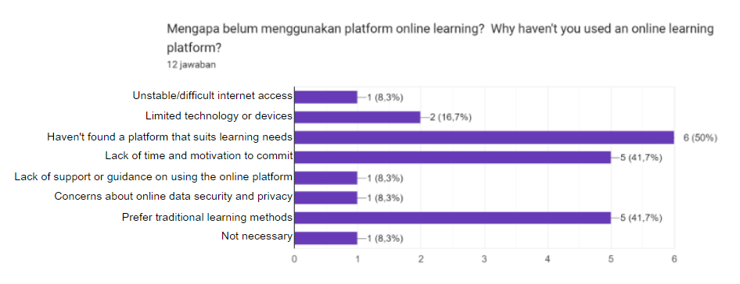Out of 54 students, there are 12 students who do not use online learning due to reasons such as unstable internet access (8.3%), limited technology/device (16.7%), did not find a platform that suits their learning needs (50%), lack of time and motivation to commit (41.7%), lack of support/guidance to use the online platform (8.3%), worried about data security (8.3%), more suitable with traditional learning methods (41.7%), and feel that traditional learning is enough (8.3%).

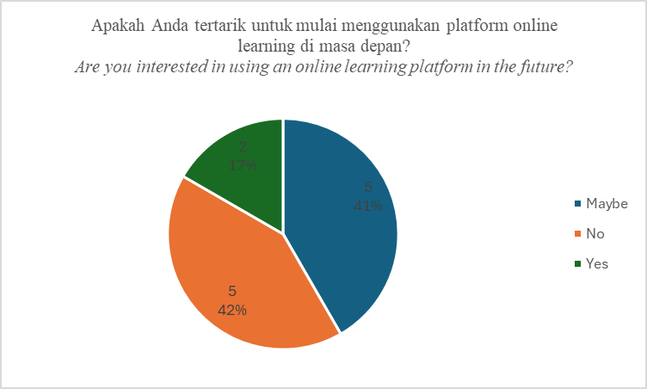Out of 54 students, there are 12 students who do not use online learning due to reasons such as unstable internet access (8.3%), limited technology/device (16.7%), did not find a platform that suits their learning needs (50%), lack of time and motivation to commit (41.7%), lack of support/guidance to use the online platform (8.3%), worried about data security (8.3%), more suitable with traditional learning methods (41.7%), and feel that traditional learning is enough (8.3%).  
  
Based on the responds that were gathered here. A literature review is conducted to explore the relevance of the responds with other research studies.

Easy to find, easy to access and low cost or free courses are factors people look for in an online learning platform which is enforced on the study by Caswell, Henson, Jensen, & Wiley on “Open Educational Resources: Enabling universal education” where there states “*Educational opportunity is the mechanism by which we fulfill that capacity. Therefore, free, and open access to educational opportunity is a basic human right. When educational materials can be electronically copied and transferred around the world at almost no cost.*” These factors are also why most respondents use YouTube as their main online learning platform because most of the educational content there is free and easy to access. [1]

Respondents mostly prefer video-based learning. This is proven by a research titled "*Instructional Video in E-learning: Assessing the Impact on Learning Outcomes and Satisfaction*" which shows that video-based learning, specifically interactive video significantly improves student engagement and learning outcomes compared to the traditional classroom and non-interactive video (linear). Students treated with interactive video scored higher in satisfaction and test scores than students in the traditional classroom or non-interactive video. While YouTube only provides non-interactive or linear videos, this still proves that video-based learning is a superior learning method.[9]

Respondents also pointed out their suggestions on integrating AI in their online learning environment. In an online learning environment, AI can take advantage of various machine learning algorithms based on vast amount of learner data. These algorithms are used to recommend associated resources based on individual learning needs and preferences of the learners.[10]

AsasaraBot is an AI chatbot used for aiding students in learning, which has enhanced Content and Language Integrated Learning (CLIL) at all levels of education. Chatbots like AsasaraBot can be used in online learning environments for dialogue that would simulate proactive verbal techniques, such as asking questions and providing feedback to keep students motivated and engaged. AsasaraBot is made for teaching secondary school students cultural content and foreign languages through dialogues on a certain topic like Minoan Civilization.[11]

1. **Conclusions**  
     
    This research explores factors that affect online learning effectiveness. Collecting data from questionnaires and evaluating the results through literature review to get more insight of the data gathered. The results show that people prefer to search for free and easy to access courses or materials and perform better with interactive video-based learning. This shows that the technology behind video-based learning needs to be more emphasized on user engagement. With today’s trend of AI, the technology could be used to develop a specific chatbot where its purpose is to aid students in their personal studies which has the potential to be even more engaging and personal than video-based learning.

**References**

[1] T. Caswell, S. Henson, M. Jensen, and D. Wiley, "Open Educational Resources: Enabling universal education," *International Review of Research in Open and Distributed Learning*, vol. 9, no. 1, 2008. [Online]. Available: <https://doi.org/10.19173/irrodl.v9i1.469>

[2] J. A. Gray and M. DiLoreto, "The Effects of Student Engagement, Student Satisfaction, and Perceived Learning in Online Learning Environments," *NCPEA International Journal of Educational Leadership Preparation*, vol. 11, no. 1, May 2016. [Online]. Available: <http://www.ncpeapublications.org>

[3] Richter, T., & McPherson, M. (2012). Open educational resources: Education for the world? Distance Education, 33(2), 201–219. <https://doi.org/10.1080/01587919.2012.692068>

[4] Chen, K. C., & Jang, S. J. (2010). Motivation in online learning: Testing a model of self-determination theory. Computers in Human Behavior, 26(4), 741–752. <https://doi.org/10.1016/j.chb.2010.01.011>

[5] J. C. Lapadat, “Written Interaction: A Key Component in Online Learning,” *Journal of Computer-Mediated Communication*, vol. 7, no. 4, pp. 0–0, Jun. 2006, doi:10.1111/j.1083-6101.2002.tb00158.x.

[6] T. Nguyen, “The Effectiveness of Online Learning: Beyond No Significant Difference and Future Horizons,” 2015.

[7] Watson, W. R., & Lee Watson, S. (2007). An argument for clarity: what are learning management systems, what are they not, and what should they become? (Vol. 51, Issue 2). <https://hal.science/hal-00692067>

[8] Akhyar, Y., Ilham Syarif, M., Fitri, A., Simbolon, P., Purnamasari, A. S., Tryana, N., & Abidin, Z. (2021). Contribution of Digital Literacy to Students’ Science Learning Outcomes in Online Learning. International Journal of Elementary Education, 5(2), 284–290. <https://ejournal.undiksha.ac.id/index.php/IJEE>   
  
[9] Zhang, D., Zhou, L., Briggs, R. O., & Nunamaker, J. F. (2006). Instructional video in e-learning: Assessing the impact of interactive video on learning effectiveness. Information and Management, 43(1), 15–27. <https://doi.org/10.1016/j.im.2005.01.004>[10] Dogan, M. E., Goru Dogan, T., & Bozkurt, A. (2023). The Use of Artificial Intelligence (AI) in Online Learning and Distance Education Processes: A Systematic Review of Empirical Studies. Applied Sciences (Switzerland), 13(5). <https://doi.org/10.3390/app13053056>

[11] Mageira, K., Pittou, D., Papasalouros, A., Kotis, K., Zangogianni, P., & Daradoumis, A. (2022). Educational AI Chatbots for Content and Language Integrated Learning. Applied Sciences (Switzerland), 12(7). <https://doi.org/10.3390/app12073239>

.